**1.Write a simple program to show inheritance in scala.**

**Source code :**

class Superclass //supper or parent class

{

val value1:String ="Assignment 15.1 example code"

}

class baseclass extends Superclass { //base or derived class extends parent class

val value2:String ="Scala Single Inheritance"

println("value1="+ value1)

println("value2="+ value2)

}

object Main{

def main(args:Array[String]):Unit={

new baseclass()

}

}

**OUTPUT:**

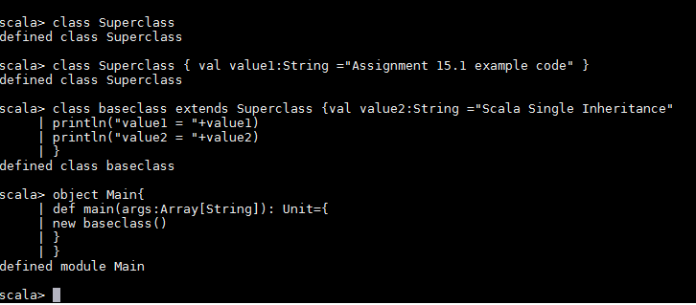

**2.Write a simple program to show multiple inheritance in scala.**

**Source code :**

trait MultipleInhertance //parent trait

{

def show() //defining the function show()

{

println("Assignment 15.1")

}

}

trait one extends MultipleInhertance //extends the parent trait

{

override def show()

{

println("This won't be printed")

}

}

trait two extends MultipleInhertance //extending the parent trait

{

override def show()

{

println("Acadgild scala multiple Inheritance example")

}

}

class three extends one with two //extending the base traits ,calling the function

show()

object MainMulti{

def main(args:Array[String]) : Unit ={

var c:three = new three

c.show()

}

}

**Output**

